
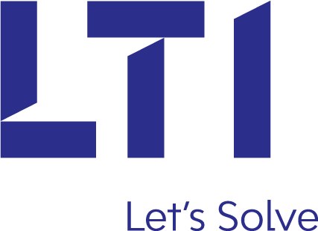


Version: 1.0

Date: 16-Oct-2017
Solution Blue Print Document
Table of Contents
Revision History 4
1 Stakeholders 5
1.1 Stakeholder Chart 5
1.2 Approvers 5
1.3 Contributing Members 5
2 Solution Overview 6
2.1 CPP Product Implementation 6
2.1.1 In Scope 7
2.1.2 Out of Scope 7
2.1.3 Assumptions 7
2.1.4 Additional Notes 7
2.2 Policy Conversion upon Renewal - Strategy 8
3 Solution Checklist 9
3.1 Major Enterprise Applications / Systems Used and Impacted 9
3.2 Data Structures Impacted 9
3.3 Infrastructure Impacted 9
3.4 Operational Impacts 10
4 Current State 11
4.1 UNICLASS – CP, GL 11
4.2 Manual Quoting and Rating – CR, IM 12
4.3 Mancom (Manual/Commercial system). 12
5 Target State 14
5.1 High-level Business Requirements 14
5.2 High-level Duck Creek Product Architecture 15
6 Solution Architecture 16
6.1 Context Model Diagram 17
6.2 Interfaces/Integrations 19
6.3 Batch Processing 21
6.4 Conceptual Data Model 23
6.5 Deployment/ Infrastructure 24
6.5.1 Policy Volume - 2016 24
6.5.2 Current Infrastructure Details 25
7 Reporting 26
8 Security 27
9 IT Operations 28
10 References 29
10.1 Business Requirements Documents – CPP Products 29
10.1.1 Crime 29
10.1.2 Property 29
10.1.3 Inland Marine 29
10.1.4 General Liability 29
10.2 Duck Creek Template – XML Schema 29
10.2.1 Crime 29
10.2.2 Property 29
10.2.3 Inland Marine 29
10.2.4 General Liability 29
10.3 CPP Integration Documents 29
10.3.1 Business Requirements Document 29
10.3.2 Interface Agreement 30
10.3.3 Other Supporting Documents 30
11 Appendices 31
11.1 Architecture Principles 31
11.2 Architecture Metrics 31
11.3 Database Schema Definition Standards 31
11.4 Utica National Insurance - Secure Coding Guidelines 31
12 Action Items 32

Revision History

Date | Version | Changed By | Summary of Changes
Sep-5-2017 | Draft 1 | Chandra Sekhar Ghosh Dastidar | First draft
Sep-27-2017 | Draft 2 | Chandra Sekhar Ghosh Dastidar | Second draft
Oct-6-2017 | Draft 3 | Chandra Sekhar Ghosh Dastidar | Incorporated comments on TIBCO infrastructure changes required
Oct-16-2017 | 1.0 | Chandra Sekhar Ghosh Dastidar | After review with Sr. Technical Delivery Lead

Sharepoint link:

https://unig.sharepoint.com/sites/Projects/CPP%20RatingAutomation/_layouts/15/guestaccess.aspx?guestaccesstoken=1DwiCUrhkduL5whH%2bIeRkDxbLhv6MV6odHNPFtiUvsQ%3d&docid=2_15d50cdf6c5ce4356838a84e4c1564a30&rev=1

Stakeholders

Stakeholder Chart
Name | Role
Amanda Mailey | Project Manager
Terri Vanderworken | Business Lead
Prerna Arora | Sr. Technical Delivery Lead
Chris Piela | Executive Sponsor

Approvers
Name | Role
Mark Henning | Enterprise Architect
Pauline Mack | Data Architect
Todd Wolfe | Integration Architect
Prerna Arora | Sr. Technical Delivery Lead
Amanda Mailey | Project Manager

Contributing Members
Name | Role
Chandra Sekhar Ghosh Dastidar | Solution Architect
Aditi Chitgupi | Integration Architect
Mark Henning | Enterprise Architect
Pauline Mack | Data Architect
Todd Wolfe | Integration Architect
Prerna Arora | Sr. Technical Delivery Lead

Solution Overview
<< High level solution overview is provided here with in-scope, out-of-scope items and assumptions>>

CPP Product Implementation

Utica is in the process of migrating their current CPP lines of business from the existing UNICLASS mainframe system to the Duck Creek Technologies’ Policy Administration platform with the intention of aligning the CPP products with ISO 2017 for following lines of business
- Commercial Property
- General Liability
- Commercial and Government Crime
- Inland Marine
- Commercial Package
Utica will sell the above products along with custom Utica coverage and forms, in the following US States: CT, DC, DE, GA, IL, MD, MA, NH, NJ, NY, NC, OH, PA, TN, SC, TX, VA, WI

Utica is adopting Duck Creek Commercial Lines templates 10.x for the above lines of business in order to align with the ISO 2017 product offerings for their new business. The existing policies belonging to the above lines of business will be converted from the UNICLASS mainframe to the Duck Creek platform upon next renewal. Business acknowledges that the target CPP products will be different than the products currently offered in the UNICLASS mainframe system.

Per below are the Duck Creek Commercial Lines Template versions to be used for phase 1 production.

Line of Business | Duck Creek Commercial Lines Template Version
Commercial Property | 10.4.1709.0 - Sep 2017
Crime | 10.3.1709.0 – Sep 2017
General Liability
Inland Marine

The CPP products mentioned above are going to be built on the existing Duck Creek CL Edge platform, which currently runs the BOP, CAuto, MA Auto, WC and Umbrella products. The target system will be hosted on the same production CL Edge environment with common database. The target Duck Creek platform version will be 6.2.1.989, which is currently being migrated from existing CL Edge production of 5.2 Duck Creek platform version. The migrated Duck Creek platform will have custom CL Edge components and integrations to external and internal systems. The new CPP products will re-use the technical architecture of the CL Edge platform and will adopt currently available custom features of screen look & feel, business workflow, transaction processing, user authorization and integrations. New interfaces and integrations, as required by the CPP products, will be built based on the existing CL Edge integration design patterns, or similar applications built on the Duck Creek technologies platform, as far as possible. Any new design should be aligned with the Utica architecture vision and guiding principles. For example, Claims coverage approval can exploit the direct DC API design currently being used for the E&O lines of business.

In Scope
- New Business (NB) Quote
- Conversion Renewals
- Real Renewals
- Short Term policies
- Transaction Timing/Scheduled Transactions
- Information Transactions
- Amendments
- Cancellations
- Rewrite
- Reinstate
- DNR
- Reverse DNR
- GL Audits

Out of Scope
    - PDM Integration for Claims coverage approval

Assumptions
- CPP products will be built on the target CL Edge platform on Duck Creek 6.2.1.989
- Quote Proposals for CPP products will be developed on OpenText ExStream technologies. This will follow the same architecture of existing CL Edge implementation for the same.
- CPP to share the same database as CL Edge
- CPP to consume existing interfaces as CL Edge with modifications for CPP LOB

Additional Notes

Policy Conversion upon Renewal - Strategy
CPP and mono-line CP, GL, CR, IM policies from the UNICLASS mainframe system will be converted to Duck Creek platform during renewal. The choice of the mono-line and package policies will depend on the implemented State scope on the CL Edge system. For the first phase only two States OH and IL are considered.

Policy conversion strategy is being outlined per below diagram:

- Extract Renewal eligible policies from the UNICLASS mainframe in CSV file format (extract all fields from the existing VSAM database for the CPP policies
- FTP policy data in CSV file format to Staging area
- Update ‘Flag’ to mark the policy ‘Not to be Renewed’ in the UNICLASS system
- Upload CSV data using ETL to Staging Database
- Create policy data in Duck Creek Session XML from Staging Database
- Create Renewal quote on the CL Edge system by submitting the Session XML
- Trigger validation/eligibility rules/interfaces on the CL Edge system
- Keep log of policy data not usable due to missing/invalid data pulled from UNICLASS
- Run Rating and premium capping for the policy on the CL Edge system
- Submit Renewal quote for UW review
- Issue Renewal on CL Edge system

Solution Checklist

Major Enterprise Applications / Systems Used and Impacted
Name | Short Description | New/ Modified/ Retired
CL Edge | - Currently being upgraded to the target Duck Creek platform version 6.2.1.989  - New CPP product lines of CP, GL, IM, CR to be added to the existing CL Edge products of BOP, WC, Umbrella, CAuto, MAAuto | Modified
UNICLASS | - Current CPP Policy Admin system will stop writing CPP policies as we go live on CL Edge with new States | Modified
UniClaims / UCP Programs | - UCP Interface programs to pull data from the Duck Creek using MQ-series  - Changes in certain CICS programs to enable CPP claims coverage approval from Duck Creek  - Maintain both UNICLASS and Duck Creek connectivity for Claims coverage approval | Modified
Data Warehouse | - Design re-factoring for the data feeds  - TAS calculation  - TAS Stand-alone application | Modified
Onbase | - CPP workflows will be created | Modified

Data Structures Impacted
Name | New/  Modified/Retired/ No Change | Subject Area | Technology & Vendor  DB2, VSAM File, SQL Server | Data Growth Size Expected
ExampleData | No Change | Duck Creek policy database | SQL Server
Data Warehouse | Modified | - New set of tables for TAS metadata and transaction history for building data  - New set of staging tables for downstream interfaces | Oracle

Infrastructure Impacted
Name | New/ Modified/ Retired | OS / Application | Change Required
CL Edge | Modified | Application | Additional resource provisioning to the current cluster of Node-based Duck Creek configuration.  Numbers will be based on the combined processing load of current and new CPP products.
Onbase | Modified | Application | Additional disk space as required. CPP Forms to be stored in Onbase system, anticipating increase in storage need for CL Edge with the new CPP products.
TIBCO BW | Modified | Application | New App nodes and App spaces to be added for CPP TIBCO services

Operational Impacts
Name | Description
Reporting Requirements Identified? | No.  Current scope has been identified to use existing UNICLASS reports  Additionally, there are existing web reports which have to be modified  - CE Usage Report  - AYS report
Disaster Recovery Requirements Identified? | Follow existing enterprise DR process
Additional licenses or products required with this project? | Verisk for ISO integrations  Identification of third-party licenses being evaluated  - Lynx  - Paragon  - AUSUM  - IVANS  - ---
Additional new blueprints, frameworks or standards are required for this project? | Follow standards of the following technologies  - Duck Creek  - TIBCO  - OSB  - Dot Net  - PL/SQL  - Onbase  - ExStream
Is there job scheduling required (SSIS, Control M or other)? | Windows based scheduling from Duck Creek  Mainframe based Jobtrack scheduler for batch processing

Current State
<< Current state of Uitca CPP implementation is highlighted here. Provide high level details of all the components/areas involved in the current solution>>

UNICLASS – CP, GL

- UNICLASS stands for
“Utica National Insurance Commercial Line Admin Support System”
- Automated P&C insurance system which was developed by Alloy group in early 70’s.
- For CPP, only two lines of Commercial Property and Commercial General Liability are being offered in the UNICLASS mainframe system.

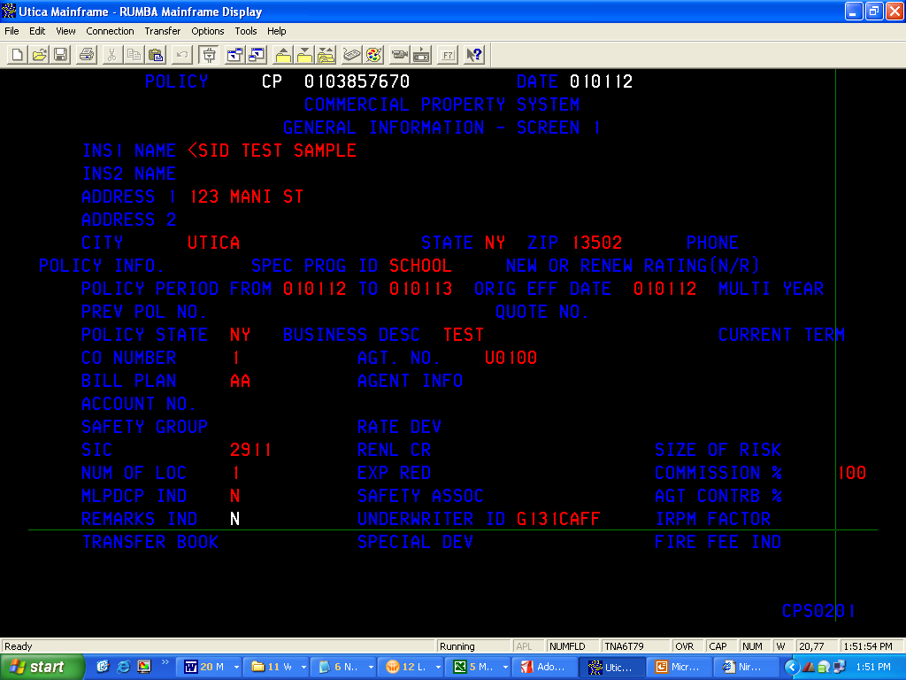

- UNICLASS has the following sub-systems
- PRINT – POLICY PRINT
- OFU – OUTPUT FORMAT UTILITY
- END – ENDORSEMENT FORMS
- LER – LOSS EXPERIENCE SYSTEM
- PAK – PACKAGE SYSTEM

PAK ensures that all parts of the package CPP policy are billed together, mailed together and have a common policy number, expiration date, company, agent and other pertinent information that is carried to each lob.

- UNICLASS has interfaces with the following systems
- CLAIMS
- UNIBILL – DIRECT BILL
- 550 – AGENT BILLING
- AGENT SYSTEMS
- FORMS
- POLICY INDEX
- AUDITC
- ISO
- DMV
- LYNX

Account distribution for the CPP lines to UniBill (Direct Bill) and 550 (Agency Bill)

Note: Utica SME provided the diagram above

Manual Quoting and Rating – CR, IM

Monoline crime is written by Bond underwriting department & they use UNICLASS, E-surity & Man/Com.
In some cases they also write manual policies for reasons, such as
- State not available
- System does not support required form
- Specific change needed by underwriter

https://www.mindmeister.com/923812332

Mancom (Manual/Commercial system).
Mancom processes policies which cannot be processed on any of the existing automated systems due to various limitations. The system does not have a policy rating engine. The rating information has to be manually entered. Premium is not calculated automatically. Rather this is done manually and fed into the system.

- Processes a specific type of policy- Ex. Multi-state Workers’ Compensation, Personal auto policies with over 4 vehicles
- A specific type of coverage – Ex. ERPLI coverage
- A specific policy program – Ex. Commercial Output Policy (COP), Umbrellas, Bonds, Texas Homeowners
- A specific policy because of problems on the automated system
- Used for processing endorsements to existing policies (For ex: UNIAPPS back-dated endorsements)
- Minimal online editing
- No database. All entry goes to the files-Mancom Entry file and 550 file
- Automated Balancing (UNITECH).- after every job step, there is a proc step to send previous steps data to Unitech so as to validate whether the counts matches or not.
- No Job track – Jobs are processed manually. No Zeke
- Mancom System code is 00. – Code to distinguish between Mancom and Automated / V7 premium policies

Note: Utica SME provided the diagram above

Target State
<< High level future state information along with the BRD link will be added here >>

Utica will have one common Duck Creek platform to write existing CL Edge policies and the newly built CPP lines. Internal users will have the ability to create both mono-line and package policies from the CL Edge system with common workflow entry-exit, user access rules and integrations. In the Phase 1 implementation, only two US States of OH and IL are being covered along with countrywide coverage, rules and forms. Policies, currently being maintained in the UNICLASS mainframe system and various source systems, will be converted to the Duck Creek CL Edge system over the multiple phases such that the legacy systems can be decommissioned gradually.

High-level Business Requirements

Commercial Property

1. ISO CP Coverages and Property Independent coverages for CW, IL & OH
2. Automated Rating & Pricing of CP risks
3. Automated generation of ISO and independent forms, quote proposals, declaration pages and rating worksheets

Commercial and Government Crime

1. ISO Crime Coverages and Independent Coverages for CW, IL & OH
2. Automated Rating & Pricing of Monoline Commercial Crime Policy
3. Automated generation of ISO and independent forms, quote proposals, declaration pages and rating worksheets

High-level Duck Creek Product Architecture

Solution Architecture

Business Architecture | - CPP lines of business, comprising of Commercial Property, General Liability, Crime, Inland Marine and Commercial Package, will be administered on the existing Duck Creek CL Edge system. Of which, CP and GL are on the mainframe UNICLASS system and CR and IM are maintained manually through Mancom system.  - The products on the new CPP platform will be aligned with the ISO 2017 and will be implemented through the Duck Creek Commercial Lines templates version 10.x  - Existing UNICLASS CPP policies will be converted to the new CPP Duck Creek platform during Renewal  - New CPP workflow will modify the existing CL Edge workflow
Application Architecture | - CPP lines of business (CP, GL, CR, IM) will be built on the Commercial Lines (CPP) Base Template version 10.0. However, common existing 9.0 base definitions for CL Edge will be ported to the new Base Template version 10.0  - Keeping the CPP lines as a separate template version will allow the templates to be upgraded monthly without impacting the existing non-CPP lines of business.  - Any changes needed in the 10.x version can be programmed or re-engineered from the 9.x Templates. Inheritance can be controlled from LOB level.  - Duck Creek Platform, Skins, and TransACT will be common to the entire CL Edge system.
Data Architecture | - CPP policy data will be stored in the same ExampleData database as being used in the current CL Edge system  - No change in the ExampleData schema  - CPP XML data schema will be new for each LOB based out of the CL template 10.x plus customization incurred
Technology Architecture | - CPP product lines will be built on top of the existing Duck Creek Technologies Platform version 6.2.1.989 of the current CL Edge system  - Quote Proposals for CPP products will be developed on OpenText ExStream technologies. This will follow the same architecture of existing CL Edge implementation.  - CPP product will continue to consume the existing CL Edge interfaces with the exception of  - Claims Coverage – using Duck Creek API call instead of PDM  - New interfaces will integrate with TIBCO service bus  - CPP will continue consuming the existing SQL DSN with non-Duck Creek databases.
Security Architecture | - CPP will follow existing CL Edge Duck Creek platform security architecture  - CPP will follow existing TIBCO, OSB, ESG security architecture  - No specific requirement for data encryption or masking

Context Model Diagram
<< Provide context model diagram for target solution >>

Interfaces/Integrations
Sl. # | Application Name | Interface Name | Integration Category | Inbound/ Outbound/ Both | New/ Existing Interface | Protocol | Middleware
1 | Data Warehouse (SYRCOM Agency system) | Agency Licensing Validation | Agency Validation | Outbound | Existing; no change | SOAP/ XML | OSB
2 | Data Warehouse (SYRCOM Agency system) | Agency Termination Validation | Agency Validation | Outbound | Existing; no change | SOAP/ XML | OSB
3,4 | Data Warehouse (SYRCOM Agency system) | Quoting Agent Validation / Prospective Agent Validation | Agency Validation | Outbound | Existing; no change | SOAP/ XML | OSB
5 | Data Warehouse (SYRCOM Agency system) | Producer Drop down | Agency Validation | Outbound | Existing; no change | SOAP/ XML | OSB
6 | Data Warehouse (Aggregate DB) | Location Scrubbing Service / DTC | Aggregate Query Interface | Outbound | Existing; no change | SOAP/ XML | OSB/ Java
7 | Data Warehouse (Aggregate DB) | Terror Targets | Aggregate Query Interface | Outbound | Existing; no change | SOAP/ XML | DWH-Java
8 | Data Warehouse (Aggregate DB) | Closest ins details and wind hail | Aggregate Query Interface | Outbound | Existing; no change | SOAP/ XML,  ODBC | OSB, DWH tables
9 | Data Warehouse  (Aggregate DB) | TAS Automation – Generate  TAS Details Screen | Aggregate Query Interface | Outbound | New | REST/ XML,  ODBC,  HTTP | TIBCO – DWH Package call,  Tight with TAS stand-alone application
10 | Unipass | CPP Scoring Engine | Unipass | Outbound | Existing; no change | SOAP/ XML | OSB
11 | Data Warehouse  (Experian tables) | Experian Brick Match | Unipass | Outbound | Existing; no change | SOAP/ XML | DWH-Java service
12 | Billing STG | Billing - Existing account number validation | Billing | Outbound | Existing; no change | SOAP/ XML | Intel ESG
13 | Billing STG | Billing - Get New Number | Billing | Outbound | Existing; no change | SOAP/ XML | Intel ESG
14 | Billing STG, Portal tables | Billing Status feed to check for current policy status | Billing | Outbound | Existing; no change | ODBC | Existing; SQL query from DCT to Portal table to get status
 | Billing STG | Get Payment Plans | Billing | Outbound | Existing; no change | SOAP/ XML | OSB
 | Billing STG | EFT Token Generation | Billing | Outbound | Existing; no change | SOAP/ XML | Intel ESG
15 | DC tables, Policy Index system | Policy Index - Get New Number | Policy Index | Outbound | Existing; no change | MQ, ODBC | Direct - MQ series (no web service)
16 | DC tables, Policy Index system | Policy Index - Conversion Renewal Number Validation | Policy Index | Outbound | Existing; no change | SOAP/ XML | DWH-Java service
17 | Uniclaims | DCT API | Claims Interfaces | Inbound | New | SOAP/XML,  MQ | TIBCO – DCT API invocation from Uniclaims
18 | Uniclaims | Uniclass | Claims Interfaces | Outbound | Existing; with change | CICS | This not an integration, Uniclaims interface programs
19 | Uniclaims | UniClaims | Claims Interfaces | Outbound | Existing; with change | CICS | This not an integration, Uniclaims CICS screen
20 | Uniclaims | Get Current ISO | Claims Interfaces | Outbound | Existing; with change | CICS | This not an integration, mainframe program changes for Claims reports, stat codes, etc.
21 | Mancom | Mancom | Claims Interfaces | Outbound | Existing; with change | CICS | This not an integration, but Mainframe screen changes
22 | Data Warehouse | Claims Loss History | Claims Interfaces | Outbound | Existing; no change | SOAP/ XML | OSB
23 | Verisk | Prometrix--ISO loss cost- specific rates contract | ISO | Outbound | New | REST/XML | TIBCO
24 | Verisk | ISO Passport(A+ Reports) | ISO | Outbound | New | REST/XML | TIBCO
25 | Verisk | PPC (New Contract) | ISO | Outbound | New | REST/XML | TIBCO
26 | N/A | Prior Loss Runs --JC? --need to go in onbase-not in scope | ISO | Outbound | N/A | N/A | Out of Scope - Not an Integration
27 | MSB (via .NET multi layer web service) | MSB ITV - exists for Bop .NB only-vendor calculates building reconstruction cost. | ISO | Outbound | Existing; no change | SOAP/XML | .NET service hosted on DCT server
29 | OnBase | OnBase | ISO | Outbound | Existing; with change | SOAP/XML | Tight
30 | OnBase | Paragon -claims --& Deductible | Claims | Outbound | N/A | N/A | No integration – Paragon user logs into OnBase to view policy
31 | Data Warehouse | Renewal Data (NOC Count, Loss Ratio, etc.) | ISO/ Data Warehouse | Outbound | Existing; no change | JDBC | OSB
32 | Data Warehouse/ USPS database | Group 1 Address Scrubbing | ISO/ Data Warehouse | Outbound | Existing; no change | JDBC | DWH-Java
33 | Compro | ComPro Account Lookup -Edge - make sure it works for cpp | ISO | Outbound | Existing; no change | SOAP/XML | Tight - Compro web service call from DCT
34 | Core Logic | Core Logic / Risk Meter ---renewal only-uw rules -existing for CA-(Debbie Testa-Renewals only | ISO | Outbound | Existing; no change | <<TBD>> | <<TBD>>
35 | Data Warehouse | Financial Report | ISO/ Data Warehouse | Outbound | New | ODBC | Tight; SQL query
36 | Google Maps | Google Maps | ISO/ Miscellaneous | Outbound | Existing; no change | HTTP | Tight
49 | Reinsurance mainframe application | Reinsurance (from Data Warehouse 550 feed) | Reinsurance | Outbound | New | MQ | TIBCO (new service) – Real time interface, not batch
59 | AuSum | AuSum - Duck Creek Audit Transactions | Miscellaneous | Inbound | Existing; with change | ODBC | Tight, DCT table
63 | Exstream Printing, OnBase | Extreme – Proposal printing  NEW SCOPE | Printing | Outbound | Existing; with change | MQ (for Exstream)  SOAP/XML (for OnBase) | Tight, MQ
64 | <<TBD>> | At Your Service Reports - My data, Pending Renewal Data  NEW SCOPE | <<TBD>> | <<TBD>> | New | <<TBD>> | <<TBD>>

Batch Processing
Sl. # | Application Name | Batch Name | Batch Category | Existing/ New Integration | Technology (DB2, VSAM File, SQL Server)
37 | Mainframe | 550 (Premium, Stat Reporting, commissions…..…) | Outbound Batch | Existing; with CPP customization | File
38 | Agency system (via IVANS server) | Agency Download | Outbound Batch | Existing; with change | XML
39 | Ausum (via Data Warehouse) | AuSum [Premium Audit Automation for audits performance and tracking(from Data Warehouse) | Outbound Batch | Existing; with CPP customization | Flat file
40 | Infogix/Assure | Balancing Feed | Outbound Batch | Existing; with CPP customization | Balancing to be built for every batch integration – not a single integration/ touch point.
41 | Billing STG | Billing- STG - (Unibill?) | Outbound Batch | Existing; with change | Flat file (80 char Card file)
42 | Agency Billing (via Data Warehouse) | Agency Bill | Outbound Batch | Existing; no change | Flat file (will use 550 File)
43 | CAT (via Data Warehouse) | Catastrophe Modeling (from Data Warehouse 550 feed) | Outbound Batch | Existing; with CPP customization | Flat file
44 | At Your Service/ Portal | CE Usage Report- web team report | Outbound Batch | Existing; with change | Stored Procedure (DC data stored in SQL server)
45 | N/A | High Value Property (can be deferred) ????--Not an Integration--uniclass report | Outbound Batch | N/A | Out of Scope - Not an Integration
46 | Lynx (via Mainframe program) | Lynx FNOL- Claims Cov Verification Part of a warehouse feed | Outbound Batch | Existing; with change | Flat file (CPP data to be merged with other existing Lynx files)
47 | Paragon (via Data Warehouse) | Paragon 3rd Party Deductibles (from Data Warehouse)- | Outbound Batch | Existing; with CPP customization | Flat file
48 | Policy Index (via Mainframe program) | Policy Index Batch File | Outbound Batch | Existing; with change | Flat file (data appended to existing file)
50 | Aggregate DB (Data Warehouse) | Aggregate Database | Outbound Batch | Existing; with new implementation approach for CPP | Flat file
51 | OnBase | OnBase | Outbound Batch | <<TBD>> | <<TBD>>
52 | Mainframe | Claims Mancom(manual) edits | Claims Interfaces | Existing; with change | Not an integration, Mainframe program changes
53 | Mainframe | UCP Batch Edit | Claims Interfaces | Existing; with change | Not an integration, Mainframe program changes
54 | Mainframe | DataMangement Table Update in UCP Batch | Claims Interfaces | Existing; with change | Not an integration, Mainframe program changes
55 | Mainframe | UCP Batch Edit for losses | Claims Get Current | Existing; with change | Not an integration, Mainframe program changes
56 | Mainframe | UCP Batch Edit for Premium | Claims Get Current | Existing; with change | Not an integration, Mainframe program changes
57 | Mainframe | DataMangement Table Update in UCP Batch | Claims Get Current | Existing; with change | Not an integration, Mainframe program changes
58 | Mainframe | Claims Mancom(manual) edits | Claims Get Current | Existing; with change | Not an integration, Mainframe program changes
60 | Duck Creek | Automated Small CPP Renewals | Miscellaneous | N/A
61 | N/A | Agency Upload/Bridging | Miscellaneous | N/A | Out of Scope
62 | Duck Creek | Request for cancellations | Miscellaneous/ Billing | Existing; with change | Flat file

Conceptual Data Model
<< Proposed conceptual data model >>

Duck Creek ExampleData Entity-Relationship-Diagram

To view the image in good resolution please double-click icon per below.

Deployment/ Infrastructure
<< Infrastructure layout diagram will be added here >>

CL Edge platform deployment diagram

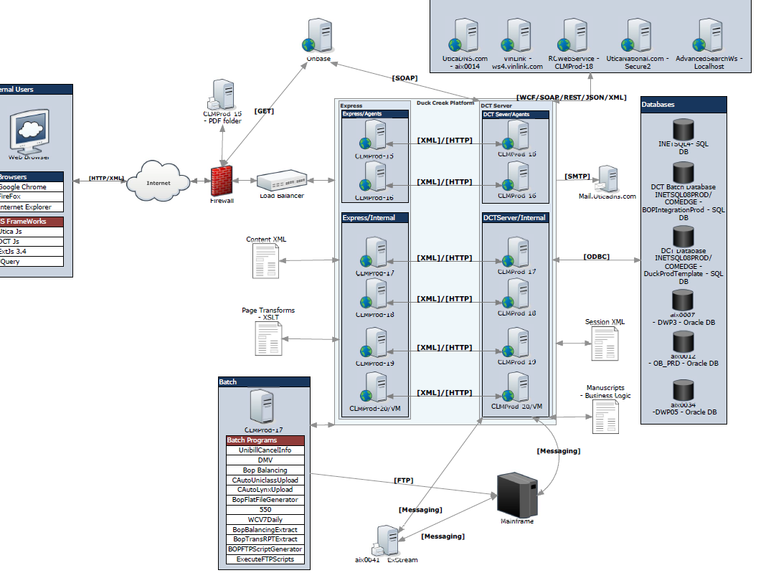

Policy Volume - 2016
LOB | Policy Count
BOP | 16,320
Cauto | 20,492
Fire | 214
Inlane Marine | 282
Multi-peril | 12,204
Fidelity/Crime | 1,179
General Liability | 12,531
Bonds | 1,448
WC | 20,393
Total | 85,063
CPP Submissions | 21,500
Hit Ratio | 11.2%

Current Infrastructure Details
<<List of servers with h/w details goes here>>

TAS application

Windows 2012 R2/IIS Web Server NETWEB1-PRD

Reporting
<< Provide details of any reporting implemented by the target solution >>

Details of reports are covered under Integration documentation.

Security
<< Security Policy – Architecture security compliance will be defined here >>

No special processing for EFT information (PII) no encryption; data masking on screen with asterisks (****) but the raw data is stored in the XML and passing to Data Warehouse as raw information.

Follow the Utica Enterprise Security Policy as described in the document attached per below

IT Operations
<< IT Operational considerations will be defined here >>

Batch schedules

Any recycling of servers etc.

Downtimes

References
<< Reference to BRD, Architecture, Data Model etc. will be listed here >>

Business Requirements Documents – CPP Products

Crime
https://unig.sharepoint.com/sites/Projects/CPP%20RatingAutomation/Shared%20Documents/3.%20Execution%20Phase/3.1%20%20Analysis%20%20%26%20BRD/LTI%20Business%20Requirement%20Documents/Product/Commercial%20Crime/Business%20Requirements/Business%20Requirements%20Document_Commercial%20Crime%209.21.17%20FINAL%20%20with%20Utica%20SME%20and%20Business%20Lead%20approvals.pdf?slrid=c6121f9e-b006-4000-0102-ff0e5b201d27

Property
https://unig.sharepoint.com/sites/Projects/CPP%20RatingAutomation/Shared%20Documents/3.%20Execution%20Phase/3.1%20%20Analysis%20%20%26%20BRD/LTI%20Business%20Requirement%20Documents/Product/Commercial%20Property/BRD/Business%20Requirements%20Document_Commercial_Property%20%20FINAL.pdf

Inland Marine

General Liability

Duck Creek Template – XML Schema

Crime

Property

Inland Marine

General Liability

CPP Integration Documents

Business Requirements Document

https://unig.sharepoint.com/sites/Projects/CPP%20RatingAutomation/Shared%20Documents/Forms/AllItems.aspx?FolderCTID=0x012000F6851A4973D0904EAB53248EB003164F&id=%2Fsites%2FProjects%2FCPP%20RatingAutomation%2FShared%20Documents%2F3%2E%20Execution%20Phase%2F3%2E1%20%20Analysis%20%20%26%20BRD%2FLTI%20Business%20Requirement%20Documents%2FIntegration

Interface Agreement

https://unig.sharepoint.com/sites/Projects/CPP%20RatingAutomation/Shared%20Documents/Forms/AllItems.aspx?FolderCTID=0x012000F6851A4973D0904EAB53248EB003164F&id=%2Fsites%2FProjects%2FCPP%20RatingAutomation%2FShared%20Documents%2F3%2E%20Execution%20Phase%2F3%2E2%20Technical%20Specifications%2FLTI%20Technical%20Specification%20Documents%2FIntegration

Other Supporting Documents

550 Integration

CR Automation for Policy Conversion

Appendices

<< Appendices if any >>

Architecture Principles

Architecture Metrics

Database Schema Definition Standards

Utica National Insurance - Secure Coding Guidelines

Action Items

<< Action items if any >>

